

What is an Entity Relationship Diagram (ERD)?

**ER Diagram** stands for Entity Relationship Diagram, also known as ERD is a diagram that displays the relationship of entity sets stored in a database. In other words, ER diagrams help to explain the logical structure of databases.

**ER diagrams are created based on three basic concepts: entities, attributes and relationships.**

ER diagrams are used to sketch out the design of a database.

Why use ER Diagrams?

* Helps you to define terms related to entity relationship modeling
* Provide a preview of how all your tables should connect, what fields are going to be on each table
* Helps to describe entities, attributes, relationships
* ER diagrams are translatable into relational tables which allows you to build databases quickly
* ER diagrams can be used by database designers as a blueprint for implementing data in specific software applications
* The database designer gains a better understanding of the information to be contained in the database with the help of ERP diagram
* ERD Diagram allows you to communicate with the logical structure of the database to users.

Following are the main components and its symbols in ER Diagrams:

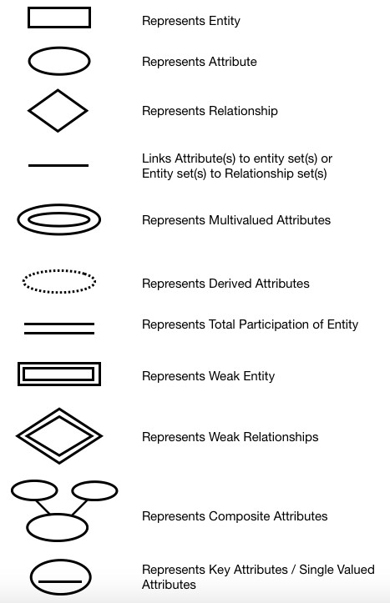

Types of DBMS Entities

The following are the types of entities in DBMS −

# Strong Entity

The strong entity has a primary key. Weak entities are dependent on strong entity. Its existence is not dependent on any other entity.Strong Entity is represented by a single rectangle.

# Weak Entity

The weak entity in DBMS do not have a primary key and are dependent on the parent entity. It mainly depends on other entities. Weak Entity is represented by double rectangle.

Mapping Constraints

A mapping constraint is a data constraint that expresses the number of entities to which another entity can be related via a relationship set.

It is most useful in describing the relationship sets that involve more than two entity sets.

For binary relationship, there are four possible mapping cardinalities. These are as follows:

1. One to one (1:1)
2. One to many (1:M)
3. Many to one (M:1)
4. Many to many (M:M)



ERD of World table :

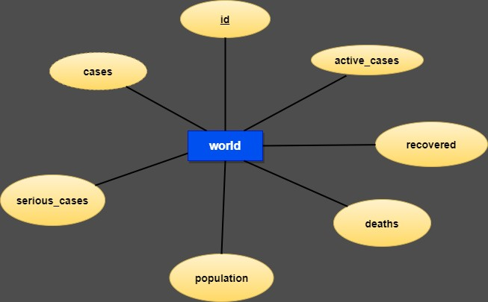

This is a strong entity table because it has a primary key which is the id attribute. There are 7 attributes in this world table(entity). This erd has no relationship in it. It has only one row in it , which shows the record of the whole world in a single row.

ERD of country_id, countries & vaccine_creation_info tables :

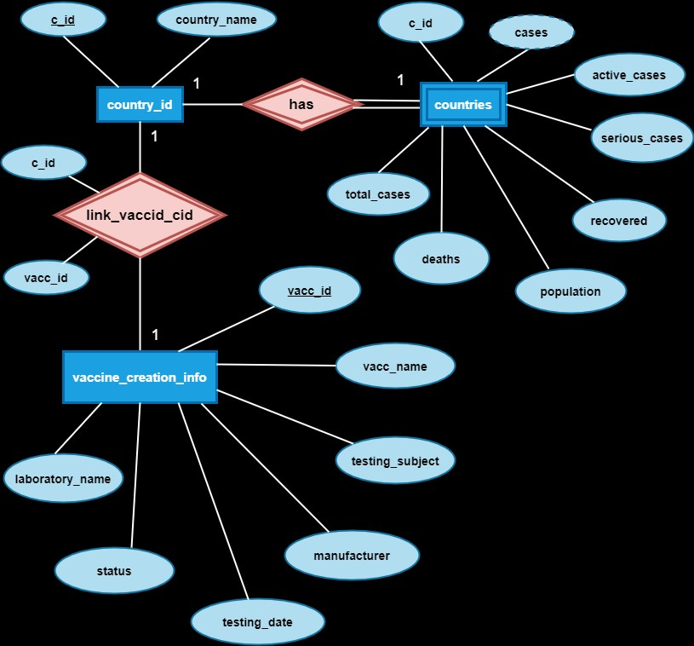

**There are 3 entities in this erd .**

1. **country_id :**

This is a strong entity with 2 attributes , c_id is the primary key over here.

1. **countries :**

This is a weak entity with 8 attributes, c_id is the foreign key here and cases is the derived attribute which is calculated using remaining attributes except population and c_id.

1. **vaccine_creation_info :**

This is a strong entity with 7 attributes , vacc_id is the primary key over here.

**This erd has 2 relatiosnhips :**

1. A relationship (has) is a relationship between the country_id entity and countries entity with a common attribute as c_id .

Here one entity is a strong entity which is country_id , because it has its own primary key but the another entity which is countries is a weak entity because it does not has any primary key but it has a foreign to link with the strong entity i.e country_id. So the here the relationship ( has ) is a identifying relationship.

It is a one to one relationship because one record of country_id table is associated with only 1 record of countries table and vice versa

1. A relationship (link_vaccid_cid) is a relationship between the country_id entity and vaccine_creation_info entity .

This link_vaccid_cid relationship has two attributes , 1 each from both the entities.The attributes of these relationship are foreign key in this relationship and primary key of their respective tables. Because it does not have any primary key, the relationship becomes a weak relationship , but with a 2 strong entities.

It is a one to one relationship because one record of country_id table is associated with only 1 record of vaccine_creation_info table and vice versa.

But this can be a many to many relationship if we add more records in it , because

1 vaccine can be supplied to many countries and 1 country can even take more than 1 vaccine.

ERD of particular countries with their respective state records.

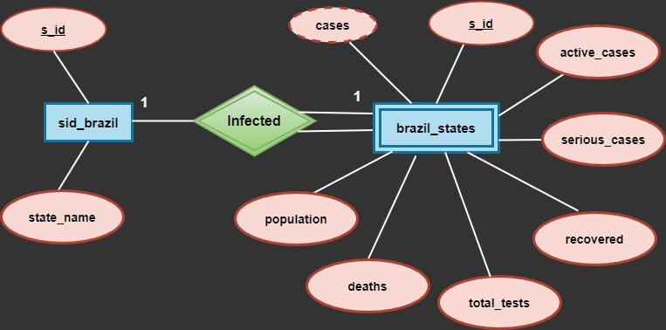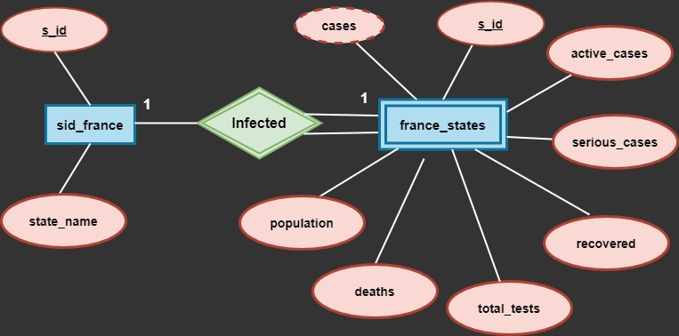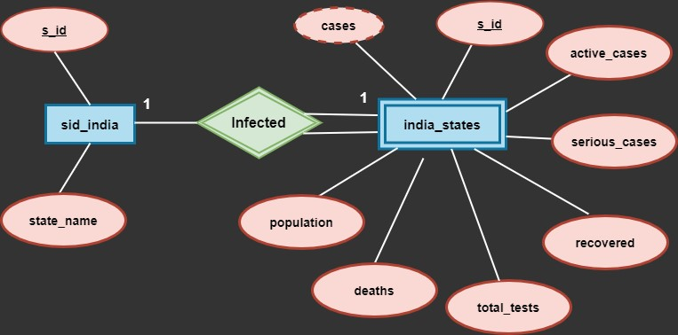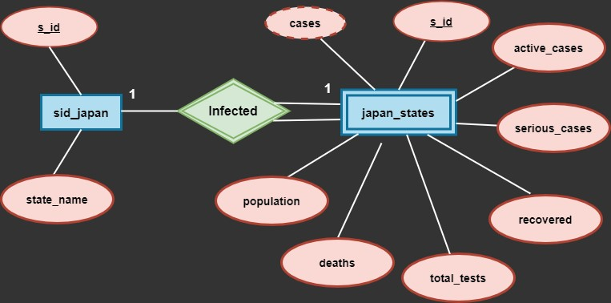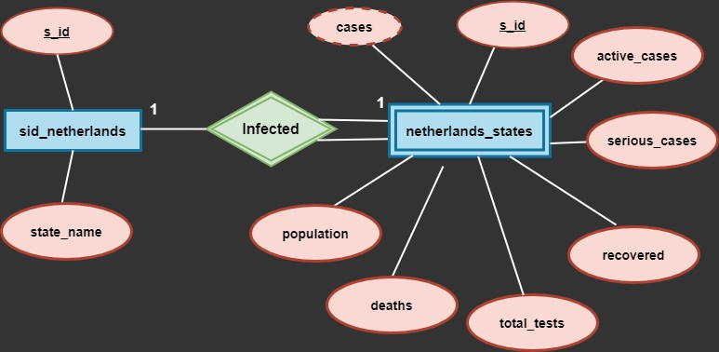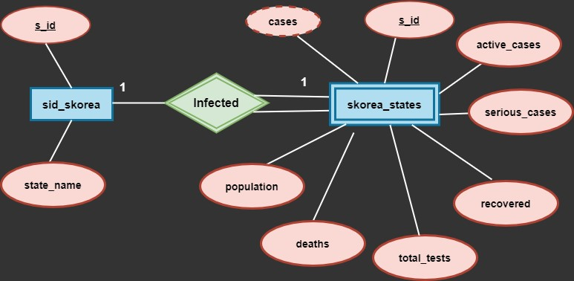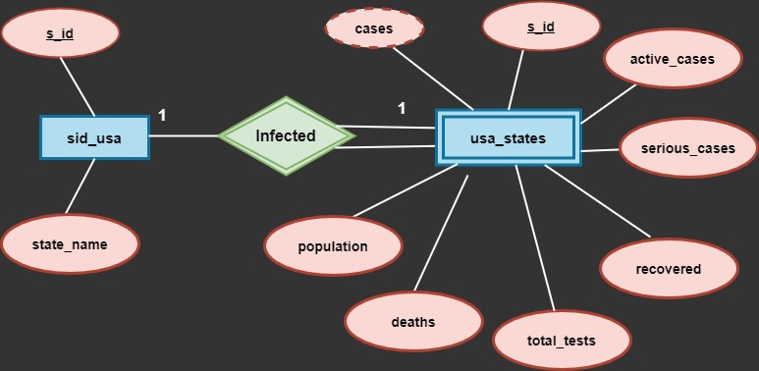

These ERD shows the records of a particular country along with their infected states.

All these ERD has 2 entites , one is strong entity which contains 2 attributes with 1 primary in them and the other entity is a weak entity , because it does not have any own primary but has a foreign key which is dependent on the strong entity The relationship (infected) between these entities is a identifying relationship.

It is a one to one relationship because, one record of a table is associated with only 1 record of another table and vice versa.